1.0 Introduction- Original Sequential Application

Overview
This application’s core purpose is to find Genome similarity using frequency vectors. The program reads a list of organism identifiers from the list.txt which loads each organism protein FASTA file saved in our data, for example we call CeHV_1 from list which loads the CeHV_1.faa, the protein sequence for Cercopithecine herpesvirus 1. After extracting the sequence, the program computes a statistical signature of 6-mer patterns for each organism. It then compares all pairs of organisms using cosine similarity and prints the similarity scores and total runtime. In essence, raw protein sequences are input, and a similarity matrix across organisms is the output.

High level architecture
The execution begins in main, where function Init is called to precompute powers of 20 used for efficient base-20 indexing for the k-mers (6-mers). The ReadInputFile is called to load names and map them to FASTA paths, which leads to calling function CompareAllBacteria to build per-organism signatures and evaluate pairwise similarities. Within CompareAllBacteria, the construction of the organism is done by instantiating a Bacteria object, which uses the relevant Fasta file, counts 6-mers with a rolling hash, estimates the expected counts under a simple background model, then converts counts to normalised signals, and finally compresses those signals into a sparse representation. The pairwise similarity is then computed by CompareBacteria, which merges the 2 vectors and returns a cosine similarity. The call tree (Figure 1) can be visualised as main -> Init -> ReadInputFile -> CompareAllBacteria -> (Bacteria::Bacteria x N) + (CompareBacteria for all i<j). This structure reflects a SISD (Single Instruction, Single Data) model, where a single thread processes one stream of instructions and data.

Processing flow and data model
Per organism, the code accumulates the following:
- A dense 6-mer count array (size 20⁶)
- A dense 5-mer count array (size 20⁵ )
- 20 single letter counts
A rolling base-20 updates the O(1) per character while scanning the FASTA. Afterwards, the 6-mer counts are estimated from the adjacent 5-mer and single letter frequency. The signal of observed-expected/expected is computed and stored sparsely as parallel index arrays.

Complexity and Expected Hotspots
Within the program, the FASTA scan is linear and efficient due to the rolling hash, but still room for improvement. The most compute-intensive single step per organism is the post-processing sweep over the entire 6-mer space (20⁶ entries), which computes the expectations and normalised signals before sparsification, consuming most CPU power and memory (Figure 1 & 2). This sweep is a prime candidate for fine-grained parallelism, where each iteration is independent and can be distributed across multiple threads. Initially it can be noted the program runs on a single thread (main thread in Figure 1), therefore the opportunity to multi-thread exists.
Figure 1: Call Tree
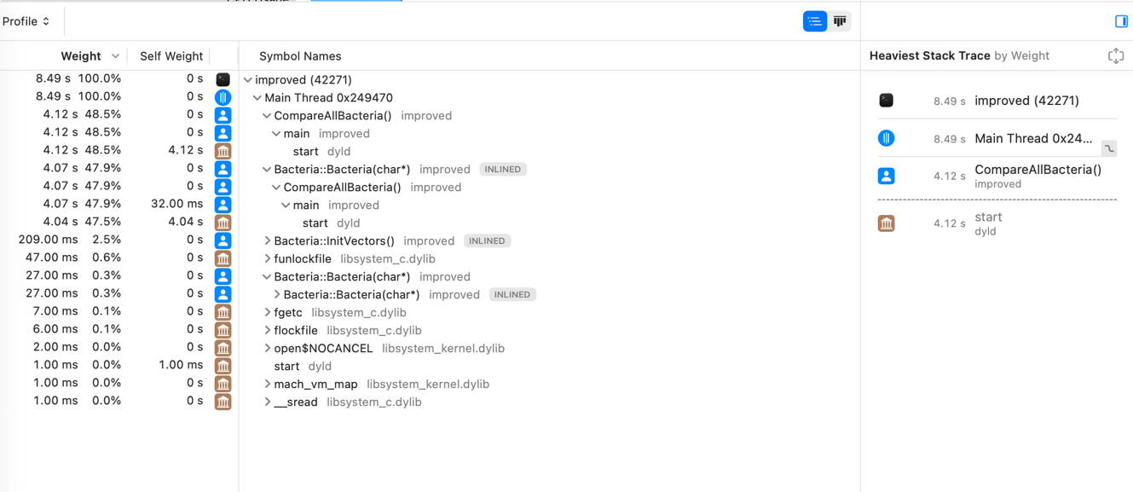
Figure 2: Flame Graph
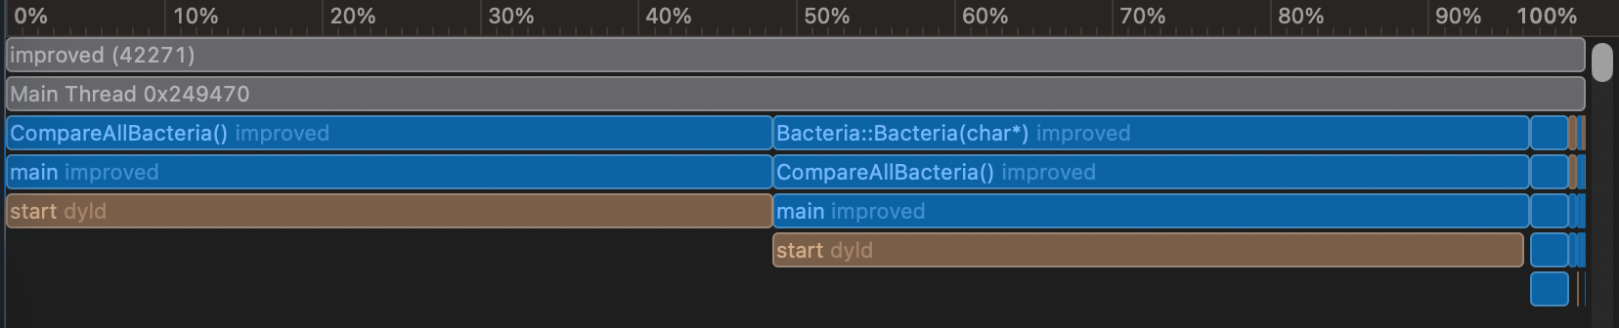

Parallelisation opportunities
The program can be parallelised by introducing 5 new methods to the work which also minorly change core logic to speed up the program, all software level parallelism.
- Per-organism parallelism: As the organisms are independent, building each Bacteria file can run concurrently (Figure 3). This is a thread-level parallelism approach, where each thread can execute an independent instruction stream, with a MIMD (Multiple Instruction, Multiple Data) architecture. This provides a sub-linear reduction in wall-time across cores. The scaling of this depends on the number of input files, limited by my Mac’s I/O, also coarse-grained. No major risks associated with parallelising this for-loop.
Figure 3: Source code targeted for per-organism parallelism (1st for loop)
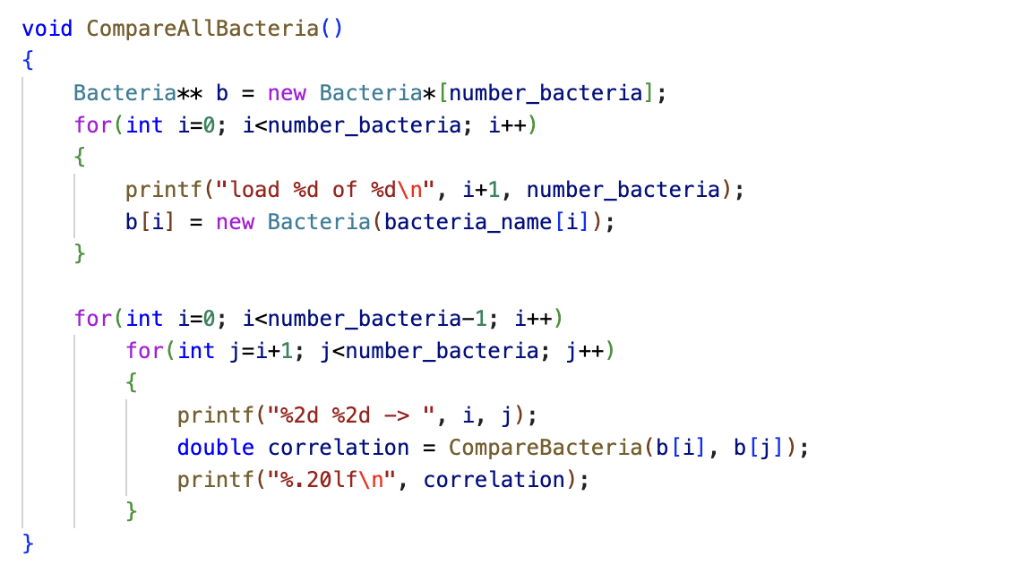

- Intra-organism parallelism on the 20⁶ sweep: the post-processing loop that computes stochastic and t[i] can be block-partitioned across threads as the i iterations are independent, then concatenated all together. Each thread writes to its own part of t[i], doing millions of iterations, enabling strong scaling on the primary hotspot based on memory limitations, fine-grained parallelism. This sweep benefits from a SIMD (Single Instruction, Multiple Data) style parallelism. Potential risks are false sharing and cache trashing.
Figure 4: Snippet of bacteria code targeted for intra-organism parallelism
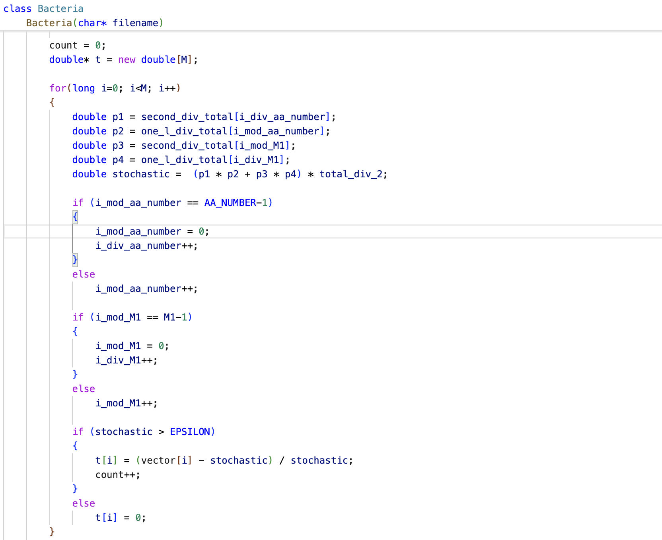
- Parallelise all-pair comparisons: tile the (i,j), i<j matrix into blocks and process tiles in parallel (Figure 5). Can instead be written via a new method with input (i,j,N) to unique slots, avoiding contention. Granularity is medium to coarse, the tasks will be processed in a O(n²/2) manner, so it will scale well as N grows, given the sparsity of vectors. Potential risks of load imbalance shall be encountered by guided code.
Figure 5: CompareAllBacteria, all pairs similarity (2nd for loop) targeted for parallelism
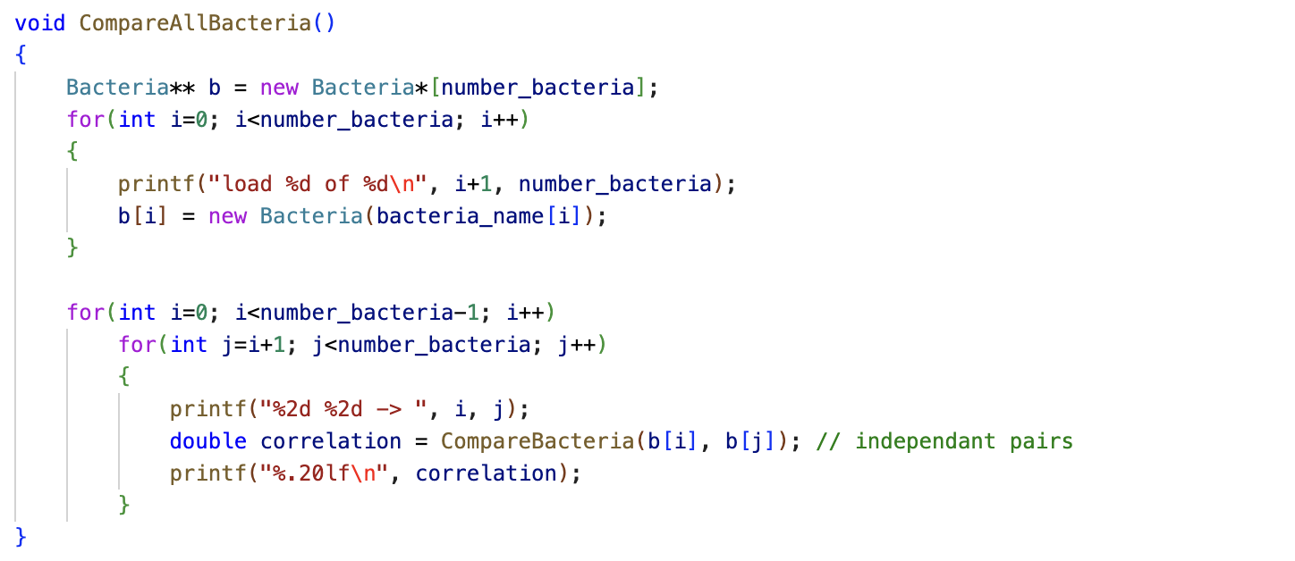

- Control/Data Flow Adjustments: To improve memory efficiency and parallelise the program further, constant pointers to key arrays will be moved outside the critical loops to improve compiler optimisation. The inner computations will be replaced with direct arithmetic operations to potentially minimise branching and the loop-carried dependencies. This adjustment reduces loop-carried dependencies and improves compiler optimisation.
- Scheduling and Synchronisation Choices: Different scheduling strategies can be applied across loops for efficient workload distribution and correctness. Static scheduling with different chunk sizes will be tested for dense uniform loops such as the intra-organism parallelisation to maximise memory locality and reduce scheduling overhead. Guided scheduling will be applied for the all-pair comparisons, to efficiently help balance workload for different organism sparsity. Synchronisation will be minimised using thread-local buffers and deterministic indexing to eliminate contention and confirming reproducible outputs.

Mapping Computation and Data Processors
The parallel design will rely on shared memory multiprocessing using OpenMP. Therefore, while sharing access to the read only data structures in the main memory, each core will run its own independent portion of the entire workload.

3.1 Computation mapping
Per-organism construction: Each Fasta file containing the organism code will be processed separately on individual threads. This approach allows multiple files to be processed simultaneously, while maintaining each files sequence parsing intact.
Intra-organism 6-mer sweep: the 20⁶ element loop will be block portioned among threads with the use of static scheduling. Each thread will handle a distinct index range of the large computational space and results will be stored privately before merging. This will lead to efficient CPU utilisation and good cache locality.
All-pair comparisons: With the use of guided scheduling, pair-wise calculations will be distributed across threads to balance work per pair. Each thread will compute its own subset of pairs to write deterministic and non-overlapping positions in the result array.

3.2 Data mapping
Read only arrays such as one_l_div_total and second_div_total will be shared across threads, whereas output buffers ti and t v will be thread local to prevent race conditions. Contiguous allocation (std::vector and pre-sized arrays) will be used for memory intensive structures to reduce false sharing and minimise cache misses. Intermediate per-thread buffers will be later merged sequentially into global arrays, ensuring deterministic and reproducible outputs. Additionally, since multiple cores may cache shared memory, cache coherence mechanisms ensure that all threads will have the most up-to-date values, particularly for these read only arrays.

Parallelisation Implementation
The OpenMP #pragma omp parallel for will be our main directive used to parallelise the CPU-intensive for-loops while we keep the codebase readable and the core functionality.
Initially, we configure the threads for predictable execution, setting an explicit thread count where required and disable dynamic resizing with omp_set_dynamic(0) and turn off nested parallel regions with omp_set_max_active_levels(1) as shown in Figure 6. OpenMP barrier semantics will handle memory consistency, because the write to memory are private and disjoint, so we will limit the use of additional synchronisation. Automatic parallelism by the compilers is limited, hence the manual approach.
Figure 6: Thread Configuration
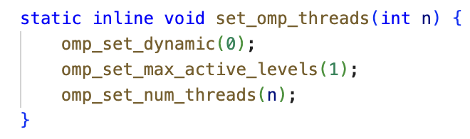
We have used static scheduling for the dense and uniform for loops such as the per-organism construction and the intra-organism sweep, with tuned chunk sizes. This choice is an implementation of instruction-level parallelism and cache-aware scheduling instead of direct memory access, overcoming a traditional von Neumann Bottleneck. The intra-organism sweep uses schedule(static, 8192) to keep the working set hot in the cache (Figure 7), the per organism sweep uses just schedule(static) (Figure 8), shelled into an omp parallel and buffers being set. Static schedule keeps the working set fresh in caches, which leads to reduced overhead. We add the nowait clause to intra-organism sweep (Figure 7), which removes implicit barriers and shortens the critical path, letting threads finish early to proceed without waiting for others.
Figure 7: 20⁶ sweep: static chunk + nowait + thread local buffers
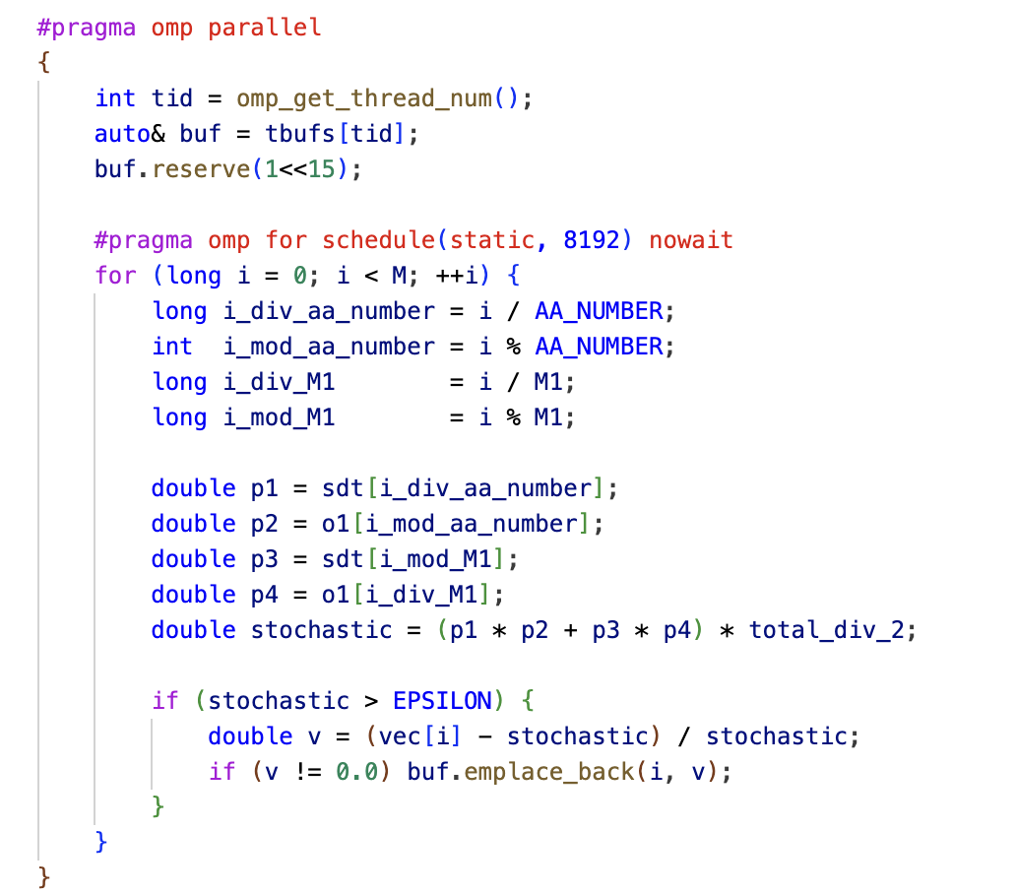

Figure 8: Per-organism build
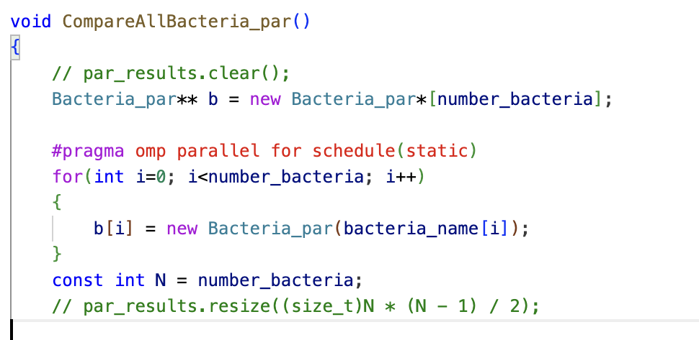
As the all-pair comparisons have uneven costs across the different organism pairs, therefore we use guided scheduling with a minimum chunk to utilise the natural load balance (Figure 9).
Figure 9: All-pairs comparisons with guided scheduling
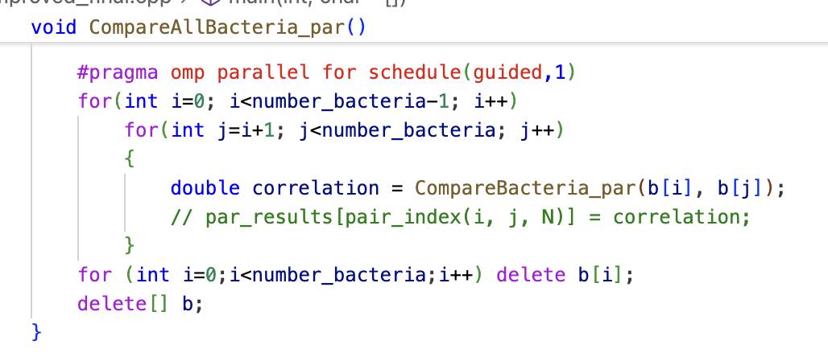
We will avoid synchronisation hotspots and maintain determinism, by having threads write only to the disjoint memory and pairwise results via a new pair_index(i,j,N) mapping (no threads will touch the same spot), and the 20⁶ accumulated into per-thread buffers, to only merge them once in a fixed order after the loop, when we choose to collect results for sanity checks, not part of core computation. This design will avoid critical and atomic sections on the program’s hot spots, eliminating lock-contention and the non-determinism that reductions can introduce (Figure 10 & 11).
Figure 10: Deterministic materialisation
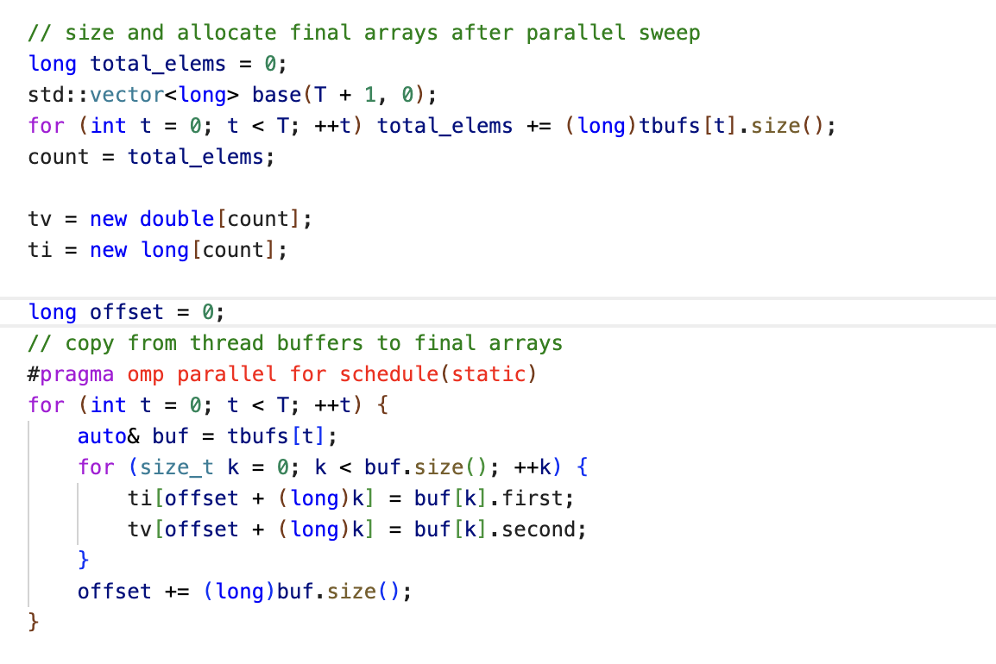

Figure 11: Disjoint writes (pair_index(I,j,N) mapping a pair into a unique slot
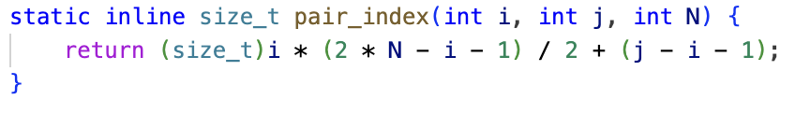
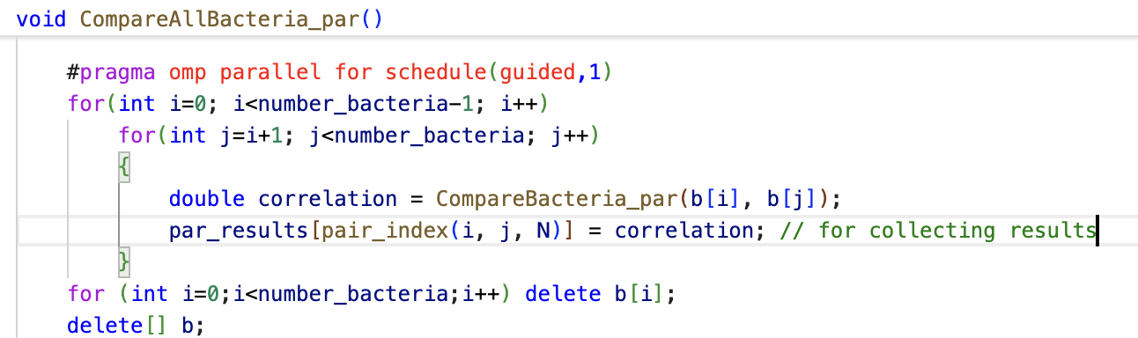
Inside the new Bacteria _par constructor, we also parallelise small uniform loops that normalise the single letter and 5-mer totals, to get minor boost.
Figure 12: Small static parallelisation
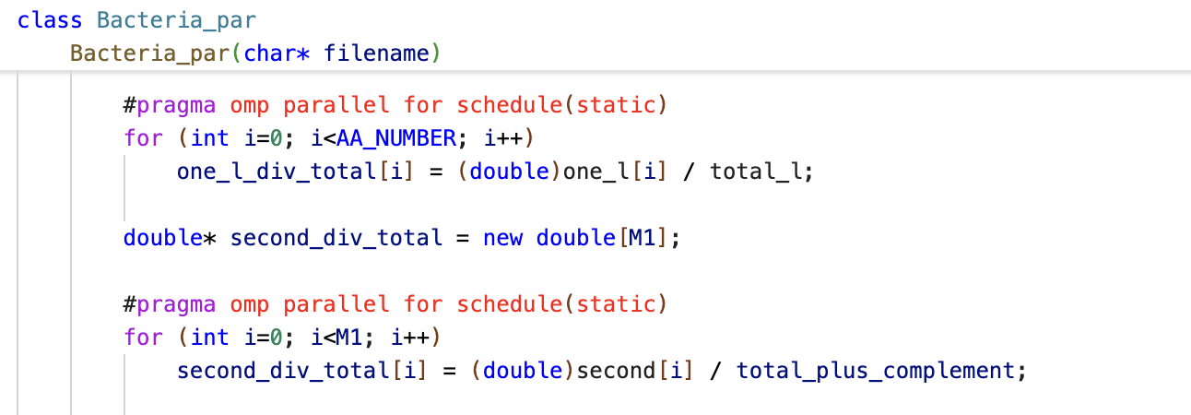
We will also disable all print functions during timed runs from ReadInputFile. The Console/file I/O is significantly slower than arithmetic and is serialised by a stream lock, so each print command will stall threads. With multiple threads, print also contend for the same lock and interleave, which inflates run-time and pollutes the caches. This methodology will provide minimum parallelising overhead, higher core utilisation, stable performance across runs, and reproducible outputs that are independent based on the numbers of cores, exactly the properties to display a parallel software.

Parallelisation Outputs
Figure 13: Post-Parallelisation Call Tree
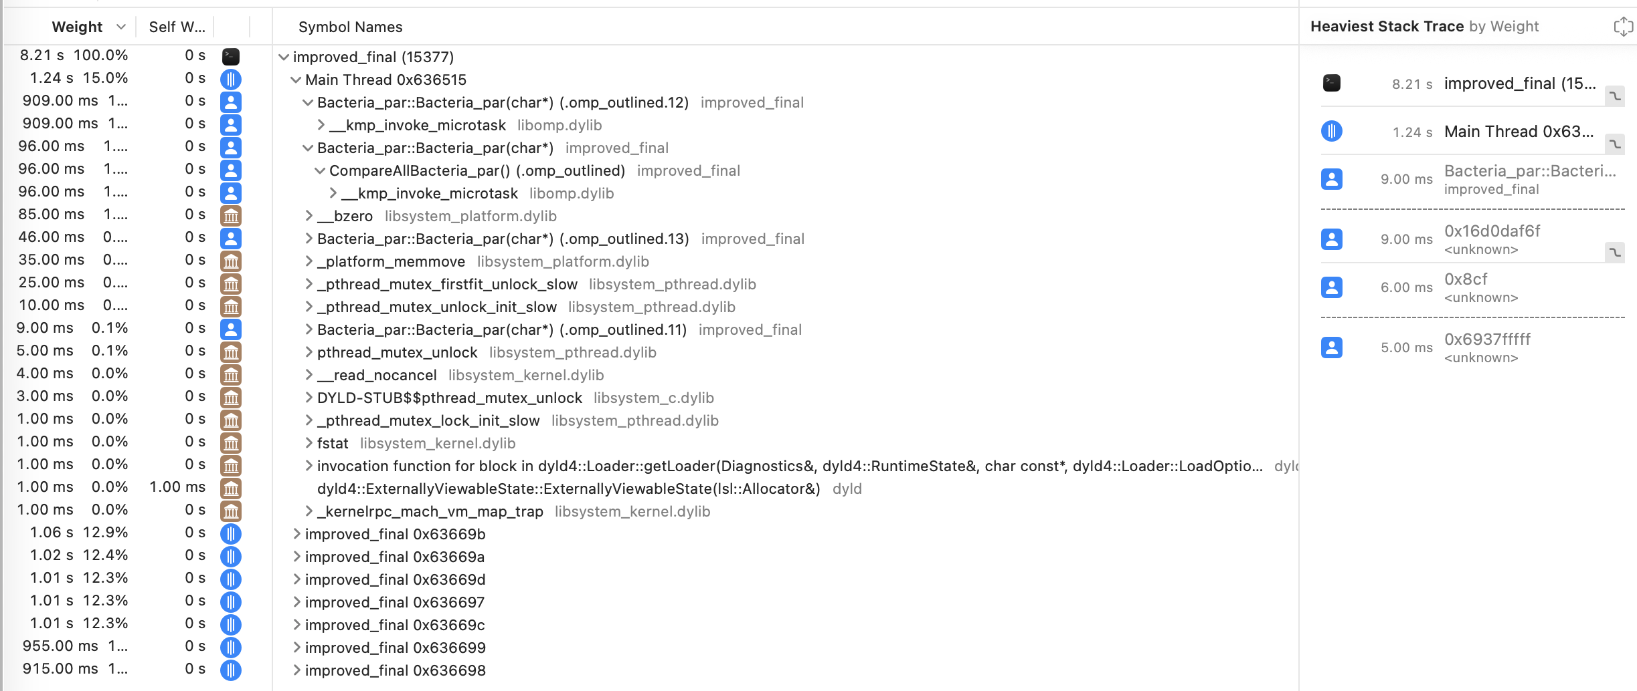
Figure 14: Flame graph
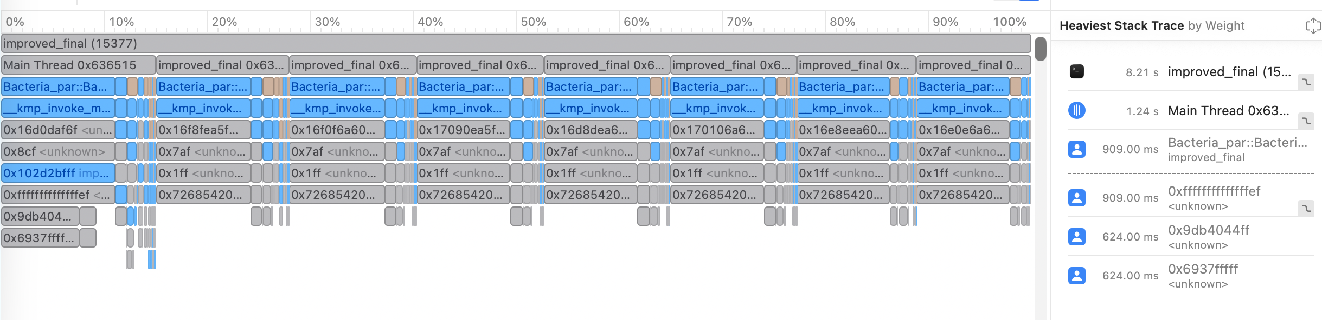
As we compare Figure 1 (sequential) and Figure 13 (Parallel), the call tree has gained new horizontal layers and multiple concurrent stacks as we have introduced parallel computing logic of OpenMP worker threads. In the sequential flame graph (Figure 2) all samples and execution sit on one main thread, whereas in our post-parallelisation flame graph (Figure 14), the multiple stacks distribute work to shorter and simultaneously operating stacks. The main thread now orchestrates the setup and merges, while the worker threads execute the heavy loops. This structure is exactly as expected when shifting from a single continuous execution stream to a multi-threaded execution under OpenMP. The heaviest stacks are now in Bacteria_par::Bacteria_par(char*), confirming the per-organism parallel stage dominates early, with the intra-organism sweep now appearing deeper in the kernel, different to our sequential call tree, where CompareAllBacteria handled the heaviest workload.
It can be visualised in Figure 13 that the weight profiling time (sum of all threads execution time) has decreased from 8.49 (Figure 1) to 8.21, but the measured execution time of the program has significantly decreased from 8.49 to 1.24 seconds. This is expected as the parallel execution shifts work of the main thread into multiple workers, leading to increased combined CPU time, while significantly reduced elapsed time. The threads can be seen running concurrently, targeting the functions to which parallel computing logic was applied, on the hotspots of Bacteria_par. Our applied logic can be seen working on their respective threads, (0x63669…), representing the OpenMP multi-thread logic. These entries in the call graph column are unsymbolised workers, which the profiler sampled inside the heavily optimised code, so it reports the binary name and an address, which has the CompareAllBacteria_par and methods from Bacteria_par, confirming the heavy work was migrated off the main thread. Finally, the self-weight column being 0s indicates the time was spent in our inner loops, rather than the thread’s entry wrapper, which indicates efficient parallel execution and profiling.
Figure 15: Speed up graph

Figure 16: Elapsed-time table
 | Sequential | 1 | 2 | 3 | 4 | 5 | 6 | 7 | 8
 | 8.315 | 3.474 | 1.903 | 1.42 | 1.174 | 1.093 | 1.063 | 1.037 | 1.036
 | 8.982 | 3.344 | 1.802 | 1.386 | 1.268 | 1.167 | 1.085 | 1.052 | 1.04
 | 8.771 | 3.312 | 1.81 | 1.386 | 1.165 | 1.127 | 1.016 | 1.356 | 1.024
 | 8.383 | 3.319 | 1.803 | 1.362 | 1.209 | 1.159 | 1.046 | 1.014 | 1.027
 | 8.59 | 3.283 | 1.84 | 1.342 | 1.254 | 1.147 | 1.06 | 0.955 | 1.051
 | 8.635 | 3.267 | 1.852 | 1.344 | 1.252 | 1.132 | 1.019 | 0.955 | 1.065
 | 8.491 | 3.267 | 1.843 | 1.342 | 1.285 | 1.152 | 1.02 | 0.943 | 1.059
 | 8.51 | 3.267 | 1.84 | 1.369 | 1.269 | 1.13 | 1.025 | 1.005 | 1.011
 | 8.514 | 3.26 | 1.982 | 1.364 | 1.25 | 1.146 | 1.017 | 1.026 | 1.078
 | 8.528 | 3.414 | 1.809 | 1.34 | 1.292 | 1.139 | 1.034 | 0.982 | 1.056
Average | 8.5719 | 3.321 | 1.848 | 1.366 | 1.2418 | 1.139 | 1.039 | 1.033 | 1.0447

Figure 15 plots the speed up of S(n) – T_{seq}/T_{n}, using our sequential average time, T_{seq} = 8.572 seconds. The best time achieved was 1.033s-1.045s using 7-8 threads, an 88% reduction time (8.3x faster) to the sequential. Notably, even 1 thread (parallel enhanced code on a single thread) provided a 61% speed-up (2.581x faster) to the sequential code, this is because of the data mapping logic and restructuring applied to the code such as tightened cache locality, fewer branches in hot loops, replaced long to uint32_t and removal of memory heavy print commands.
We can see a logarithmic speed up trend on Figure 16, initial speed up is noticeable on the lower cores through 1-5 threads (S(2) = 4.64x, S(3) = 6.28x, S(4) = 6.9x and S(5) = 7.52x) and then the speed-up slowly flattens from core 6-8 (S(6) = 8.26x, S(8) = 8.3), showing unavoidable overhead computing that occurs (I/O + merges), especially on 8 threads as the time is greater than thread 6 & 7. Using 8 cores provides a noticeable difference compared to 7 cores, this could be an outlier due to computation times recorded in different conditions. Our thread parallel scaling from thread 1 to 8 was 3.18x, which is acceptable given the execution time span and overheads. This scaling trend reflects Amdahl’s Law, where speedup is limited by the fraction of the program that is still sequential. The plateau beyond 6 threads suggests diminishing returns due to memory bandwidth and overheads
Our execution time decrease monotonically as the thread count increases, confirming good load balance of the implemented static sweeps and guided pairs. The largest gains occur up to thread 6, beyond that the returns are limited to memory bandwidth and overhead non-parallel work. Overall, the program speed transitions from 8.57 seconds to 1.033 seconds, an 88% noticeable speed up.

Testing Results
To ensure the parallel output was the same as the sequential output, a function was created to compare both sequential and parallel results called compare_results() (Figure 17). First, both the sequential and parallel programs are run to save the vector results (seq_results & par_results), placed inside the relevant for loops that write the results. The function accepts 2 equally sized vectors std::vector<double>, a tolerance tol (set to 1e -12), and an optional pointer max_abs_out. It performs a single linear scan, computing the absolute difference at each position and tracking the largest observed deviation. If any elements exceed tol, the function will immediately return false, exiting program early as 1 vector is already wrong. If the scan is completed without any violation, the function returns true. Disregarding the Boolean output, a max_abs_out is provided, the routine writes the maximum absolute difference encountered, used to determine how different the sequential and parallel outputs are. This function is put outside the timed region of the program as it isn’t associated to the core computation, rather a sanity check. The max_abs_output was an optional feature I added to improve debugging, as a Boolean value was informative. This deterministic comparison ensured reproducibility, as race conditions and non-determinism can compromise correctness.
Figure 17: compare_results function to compare sequential and parallel results with supporting function
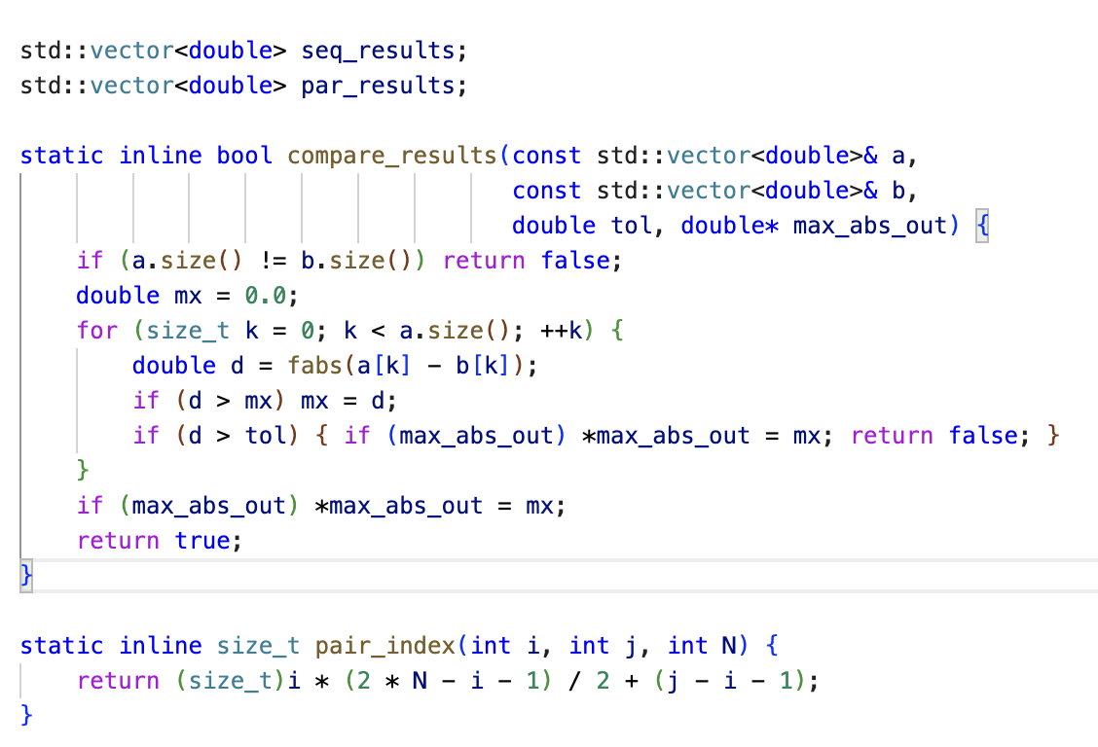

Overcoming Performance Barriers
As mentioned in Parallelisation Implementations, we iterated through several bottlenecks exposed by our profiling results and addressed each with targeted changed to improve efficiency and execution time. Early runs showed uneven work across organism pairs due to different sparsity and cost. Switching the all-pairs comparison loop to schedule(guided,1) kept incoming cores busy and provided sufficient speed up even at 6-8 threads. This change is visible in the parallel program call tree (Figure 13 and appendix 1), as we call more uniform worker stacks. The intra-organism sweep was memory-intensive, we adopted static chunking with a tuned block size (8192), so each thread processes contiguous indices, improving cache locality. This tuning follows the concept of parallelism granularity, where coarse-grain tasks reduce scheduling overhead and fine-grained tasks improve load distribution. We also introduced per-thread buffer tuples and performed one deterministic merge after the loop to avoid. Added nowait on the 6-mer sweep to avoid threads stalling until other threads finish, shortening the critical path and increasing overlap between prep and compute loops. We disabled all print commands and result comparison for timed-only runs to avoid unnecessary computing, can be re-enables swiftly, however will take longer. Loop granularity and thread behaviour were tuned for stable scaling and repeatable measurements using the omp_set_thread method. Independent of parallelism, we refined the inner loop arithmetic (fewer branches, only necessary operations) and used uint32_t counters to lower memory traffic instead of long. Together all these barriers were overcome to achieve an 88% wall-time reduction and execution in 1.03 seconds, with some tests even under 1 second (Figure 16).
A recap on the parallelisation we used OpenMP parallel for loops with schedule(static,8192), schedule(static) and schedule(guided,1), with a nowait where independence is guaranteed so per-thread buffers and a single order merge avoid locks and determinism. The final code count is 340 (including new comments and code) lines compared to the original 312, so not much code was added.

Tools and Technologies Used
The program was developed on macOS software using a MacBook Air M4, using Visual Studio Code (C/C++ Extension) with the clang/Apple Clang and the LLVM OpenMP runtime (libomp). Build used a high-optimisation, profiler-friendly configuration:
clang++ -O3 -DNDEBUG -std=c++17 -fno-omit-frame-pointer \
-Xpreprocessor -fopenmp \
-I"$LIBOMP/include" \
improved_final.cpp \
-L"$LIBOMP/lib" -Wl,-rpath,"$LIBOMP/lib" -lomp \
-o improved_final

The -O3 and -DNDEBUG flags maximise the performance, where -std=c++17 sets language level and -fno-omit-frame-pointer preserve frame pointers so Apple Instruments can later accurately attribute samples on OpenMP worker threads. OpenMP support is enabled via the -Xpreprocessor and is linked explicitly with lomp and a rpath for runtime execution. Timing and framing of the program execution was collected using the Apple Instruments’ Time Profiler, providing a call tree and flame graph.

Reflection
This project has been very helpful in advancing my understanding of parallelising code. My objective after reviewing the code was to hopefully get the execution time to 1.5-2s. Understanding the code took a bit of time because the core functionality seemed complicated at first sight, but I understood in the early stages. I straight away identified the excessive use of for loops within the program that could be parallelised to significantly reduce the execution time. Using knowledge from CAB401 tutorial work, I realised using the same OpenMP methodology would be easiest for me to integrate into the code. I tested each for loop separately to see if they provided speed up, which they all did. I ran into an issue with the all-pair comparisons, the code continued to speed up on lower cores, but at 5-8 cores, the execution time started to increase. This was because pairs involving denser organisms cost more time. Therefore, I did some research on OpenMP runtime and why this issue is occurring and realised I should use a guided schedule to redistribute the late work and keep all cores busy until the end, showing speed up on later cores. Also, along the way, I tested removing the print statements to see if the timing difference was noticeable, which it was. Overall, this project has taught me so much about parallelisation. I didn’t get to use mutexes within the program due to disjoint memory writes, but in the profiler, OpenMP within each thread had its own library-internal locks, as an in-built mechanism (Figure 13). Overall, this project was an exciting adventure. There is a possibility I can speed up the program even further than 1.03s, but my knowledge is still limited.

Commands to compile
Before compiling ensure the list.txt file and a folder labelled “data” has all the organism structure in .faa files.
To compile/build the parallelised code on a MacBook, which I used:
- Install x-code CLT and the OpenMP Library:
xcode-select --install
brew install libomp
- Set the LIBOMP env var once:
export LIBOMP="$(brew --prefix libomp)"
- Set the preferred thread count in the main function (replace n to desired threads):
set_omp_threads(n)

- Open terminal, build with the following command in the folder with the data, improved_final.cpp file and list.txt:
clang++ -O3 -DNDEBUG -std=c++17 -fno-omit-frame-pointer \
-Xpreprocessor -fopenmp \
-I"$LIBOMP/include" \
improved_final.cpp \
-L"$LIBOMP/lib" -Wl,-rpath,"$LIBOMP/lib" -lomp \
-o improved_final
- Run ./improved_final on the terminal and it should print out a statement with time taken for the parallel code to run
- Repeat instructions 4-5 but with improved_final_check.cpp in instruction 4 instead of improved_final.cpp, which runs and prints both sequential and parallel time, however it takes longer than the improved_final file as it has more functions and variables to check outputs. The original file is also included in folder labelled improved_original.cpp, which can be run, but is configured to run on MacOS only.

